Set 5: Website Analytics
Dataset: Website Traffic
Date | Page Views | Click-through Rate
2023-01-01 | 1500 | 2.3%
2023-01-02 | 1600 | 2.7%
2023-01-03 | 1400 | 2.0%
2023-01-04 | 1650 | 2.4%
2023-01-05 | 1800 | 2.6%

Question 1: Line Chart of Daily Page Views
Create a line chart to visualize the trend in daily page views over time. Label the axes and title the chart.
Answer:
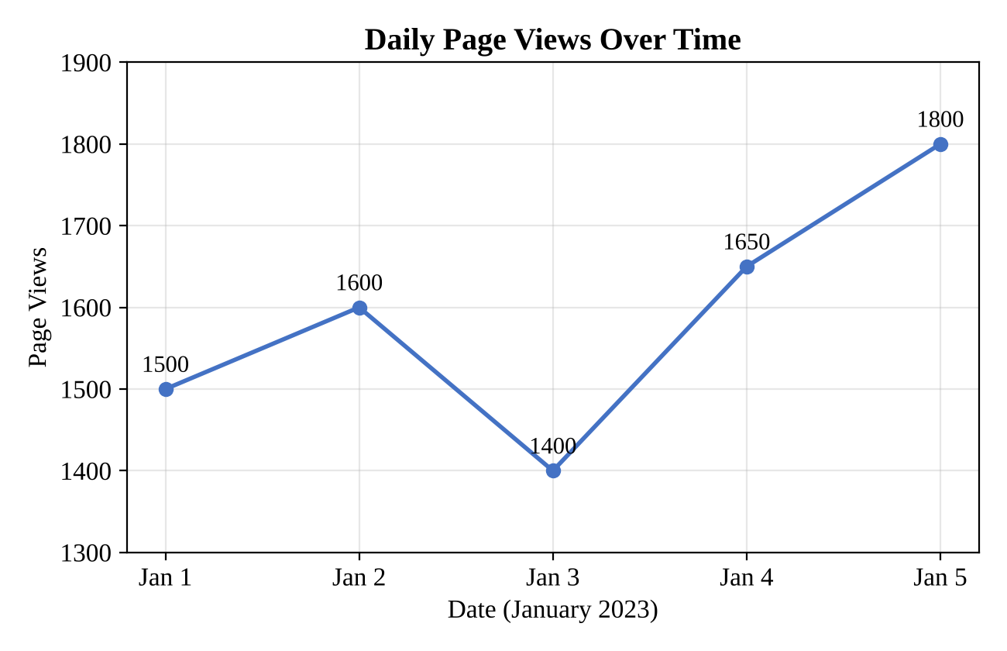
Page views began at 1500 on 1 January, rose to 1600 on 2 January, and then fell to the lowest point of 1400 on 3 January. They recovered to 1650 on 4 January and reached the highest value of 1800 on 5 January. Apart from the dip on 3 January, the overall trend over the five days is upward, with page views increasing by 300 (20%) from the first day to the last.
Question 2: Bar Chart of Top Days by Click-through Rate
Generate a bar chart showing the top N days with the highest click-through rates. Label the chart elements.
Answer:
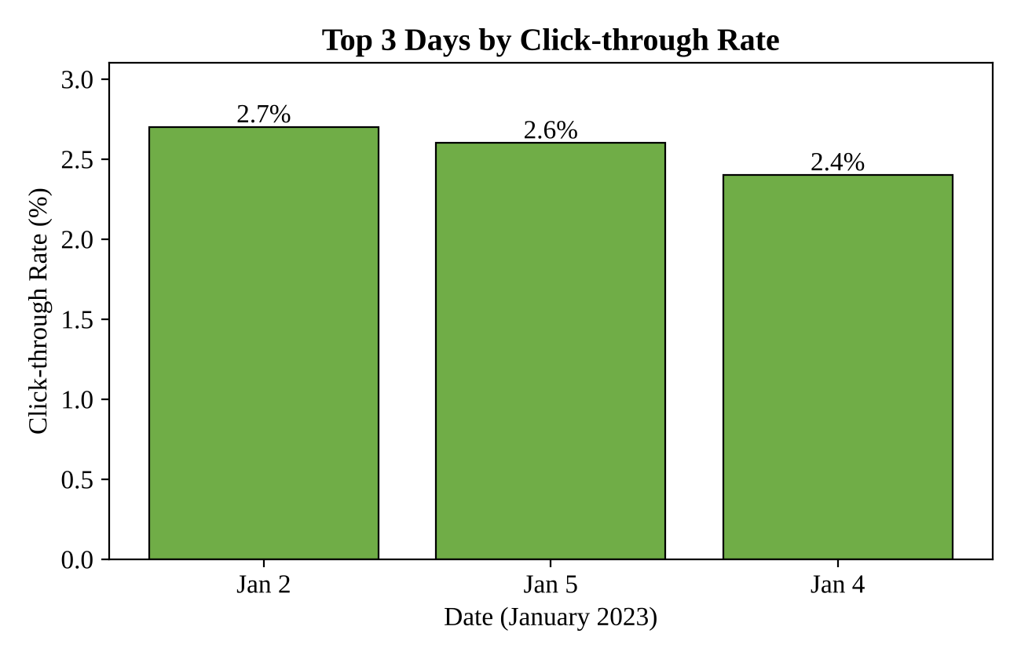
Here N is taken as 3. The three days with the highest click-through rates are 2 January (2.7%), 5 January (2.6%) and 4 January (2.4%). The lowest rate was 2.0% on 3 January, the same day on which page views were also at their lowest. N can be changed to any other value by selecting a different number of days from the sorted data.
Question 3: Stacked Area Chart of User Interactions
Develop a stacked area chart to display the distribution of user interactions (likes, shares, comments) on a website.
Answer:
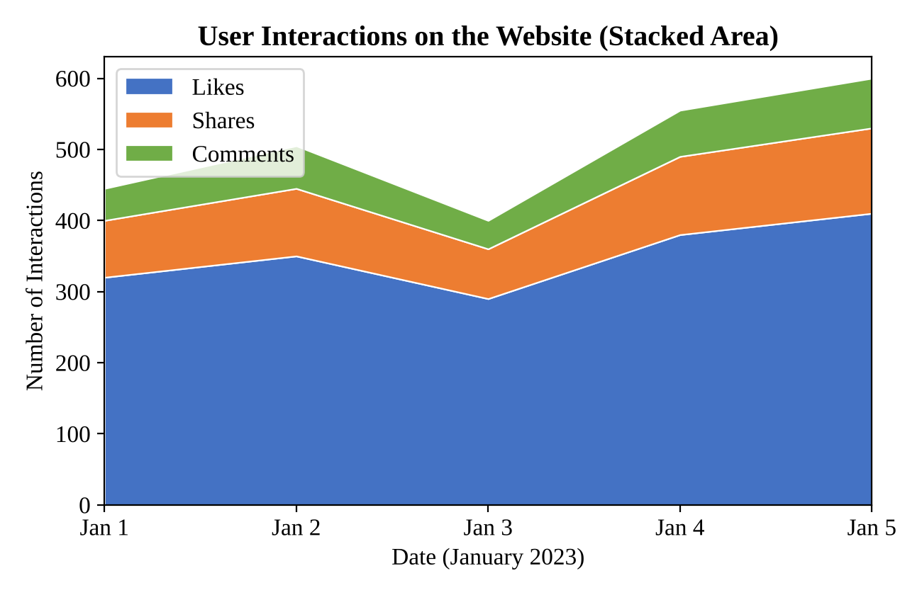
Note: the dataset has no columns for likes, shares or comments, so the interaction counts in this chart are sample (illustrative) values. They should be replaced with the real figures when they are available.
In the chart, likes make up the largest share of interactions on every day, followed by shares and then comments. The total number of interactions rises over the five days, and the three layers grow together, which suggests that all types of engagement increase along with traffic.
Question 4: Tableau Dashboard
Build a Tableau dashboard with the line chart and bar chart for interactive exploration of website traffic data.
Answer:
Tableau is a desktop application, so the dashboard file itself cannot be created inside this document. The preview below shows the intended layout, and the steps explain how to build it.
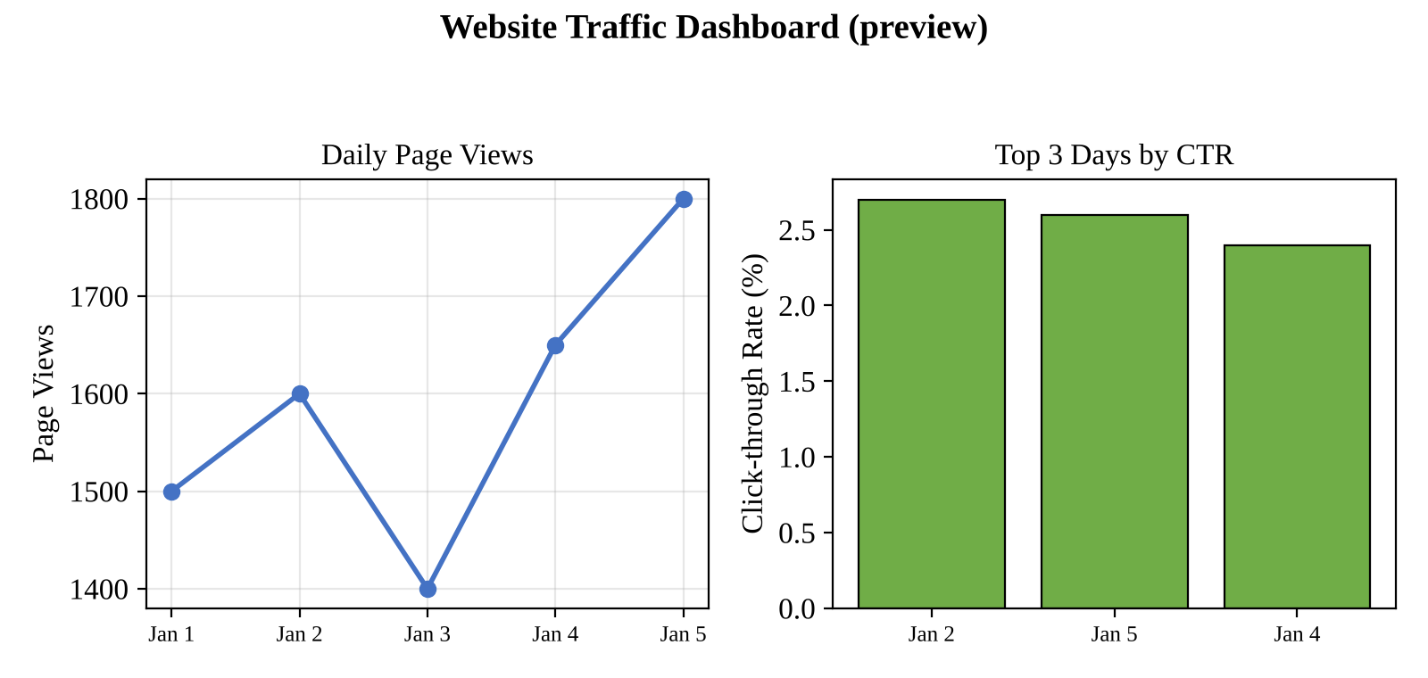
- Open Tableau and connect to the data file (website_traffic.csv or an Excel sheet). Make sure Date is a Date field and Click-through Rate is a number.
- Sheet 1 (line chart): drag Date to Columns and choose the day level, then drag Page Views to Rows. Title the sheet “Daily Page Views”.
- Sheet 2 (bar chart): drag Date to Columns and Click-through Rate to Rows. Right-click Date, choose Filter, then Top, and select the top 3 by Click-through Rate. Sort in descending order.
- Create a new dashboard, drag both sheets onto it, and set the size to Automatic.
- Add interactivity: turn on “Use as Filter” for each sheet, add a Date range filter, and keep tooltips on.
- Add a dashboard title, then save the workbook (.twbx), or publish it to Tableau Public.

